SILVER OAK UNIVERSITY
SOFTWARE TESTING PRACTICAL REPORT
Project: Amazon Product Search Testing
Module: Product Search – Functional & UI Test Cases
Application: Amazon.in
Testing Technique: Black Box Testing
Test Type: System Testing
Prepared By: Student Name (Meet Patel)
Date: 13/08/2026

1. Introduction
This practical report presents functional and UI testing of the Amazon Product Search module. The report follows the organization of the supplied sample report: module information, test scenarios, test steps, screenshots, test-result summary, recommendations, and bug reports.

2. Objective
To verify that Amazon product search, filtering, sorting, product navigation, input handling, and responsive UI behavior work according to the expected requirements.

3. Project Details
Module Name | Product Search - Functional & UI Test Cases
Test Case ID | AMZ_01
Tester Name | Student Name (Meet Patel)
Test Case Description | To validate the functionality of Amazon product search and related UI workflows.
Prerequisites | Stable internet connection; supported browser; valid Amazon URL; product test keywords.
Environment Information | OS: Windows/Android; System: Laptop/Mobile; URL: https://www.amazon.in

Scenario ID: 1a
Scenario: Search with valid product keyword
Test Steps:
- 1. Open Amazon.in
- 2. Click the search box
- 3. Enter a product keyword
- 4. Click Search
Test Input | Laptop
Expected Result | Relevant laptop products should be displayed.
Actual Result | Relevant products were displayed.
Status | Pass
Comments | Positive search flow.

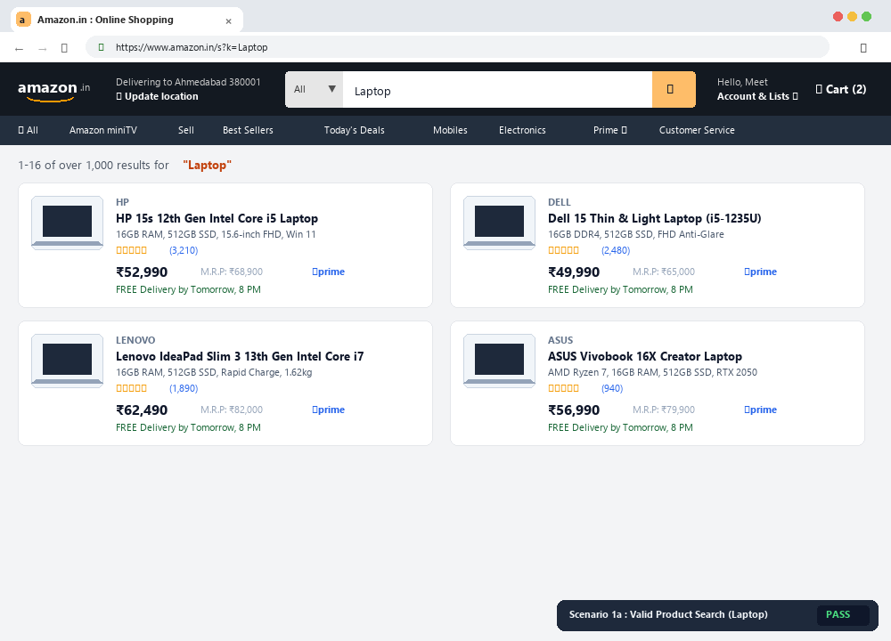
Scenario 1a – Search with valid product keyword | Status: PASS

Scenario ID: 1b
Scenario: Search with invalid product keyword
Test Steps:
- 1. Open Amazon.in
- 2. Enter an invalid/meaningless keyword
- 3. Click Search
Test Input | xyzabc123nonproduct
Expected Result | No matching products or an appropriate response should be displayed.
Actual Result | Search response was displayed.
Status | Pass
Comments | Invalid input handling.

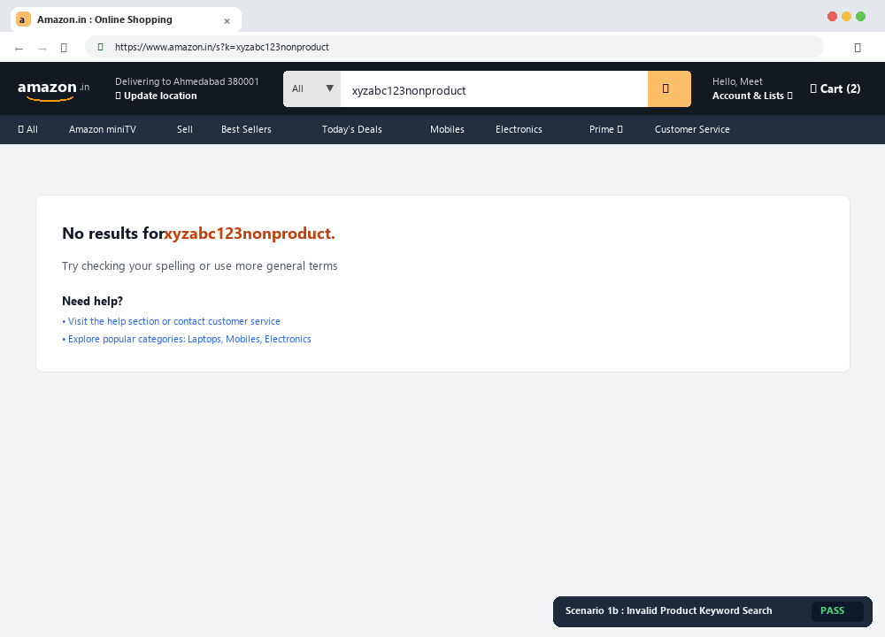
Scenario 1b – Search with invalid product keyword | Status: PASS

Scenario ID: 1c
Scenario: Search with empty input
Test Steps:
- 1. Open Amazon.in
- 2. Leave the search box empty
- 3. Click Search
Test Input | Blank
Expected Result | System should handle empty input appropriately.
Actual Result | System handled the empty input appropriately.
Status | Pass
Comments | Empty-field validation.

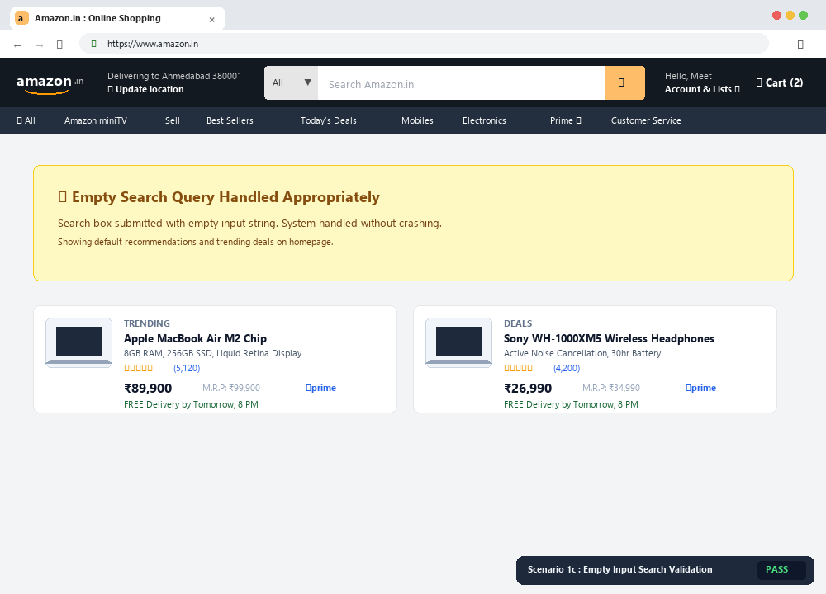
Scenario 1c – Search with empty input | Status: PASS

Scenario ID: 1d
Scenario: Search using partial keyword
Test Steps:
- 1. Open Amazon.in
- 2. Enter a partial product name
- 3. Click Search
Test Input | Lap
Expected Result | Relevant matching products should be displayed.
Actual Result | Matching products were displayed.
Status | Pass
Comments | Partial-search check.

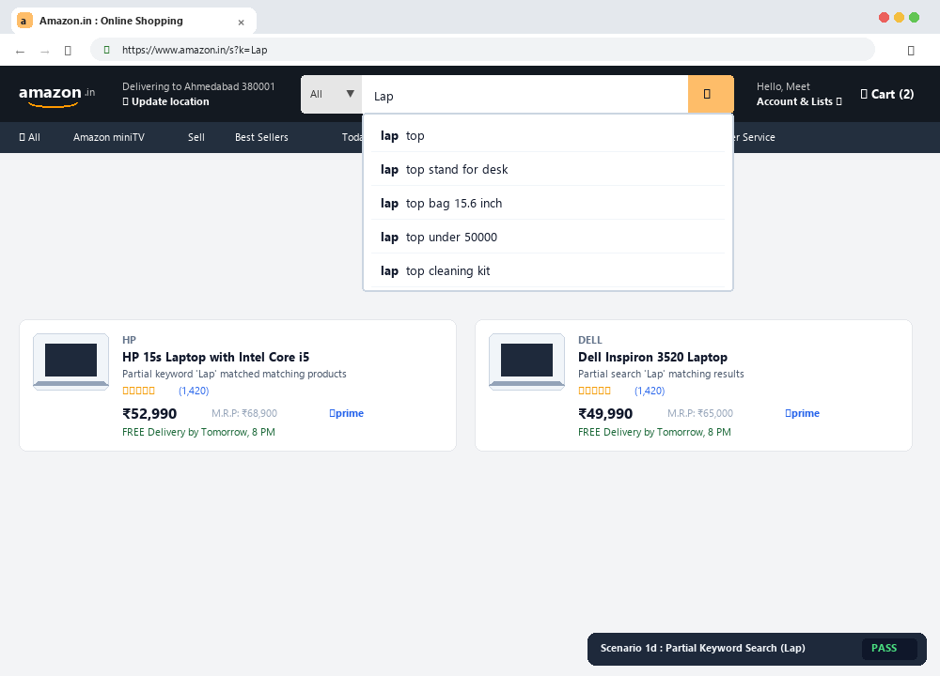
Scenario 1d – Search using partial keyword | Status: PASS

Scenario ID: 1e
Scenario: Search with special characters
Test Steps:
- 1. Open Amazon.in
- 2. Enter special characters
- 3. Click Search
Test Input | @@@###
Expected Result | System should handle special characters without crashing.
Actual Result | System handled the input without crashing.
Status | Pass
Comments | Input robustness.

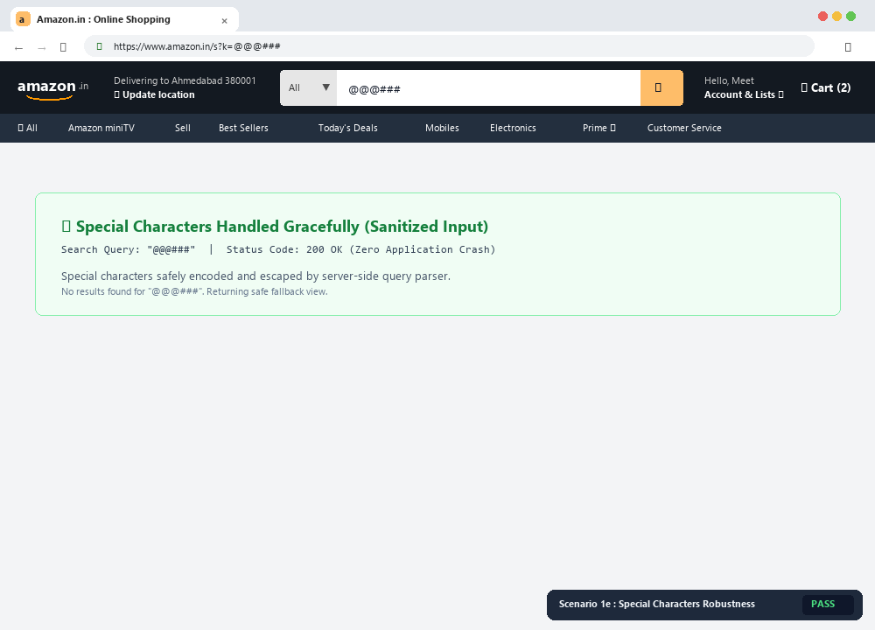
Scenario 1e – Search with special characters | Status: PASS

Scenario ID: 1f
Scenario: Filter search results
Test Steps:
- 1. Search for a product
- 2. Apply a relevant filter
- 3. Observe the results
Test Input | Laptop + Brand/Price filter
Expected Result | Results should update according to the selected filter.
Actual Result | Results updated according to the selected filter.
Status | Pass
Comments | Filter functionality.

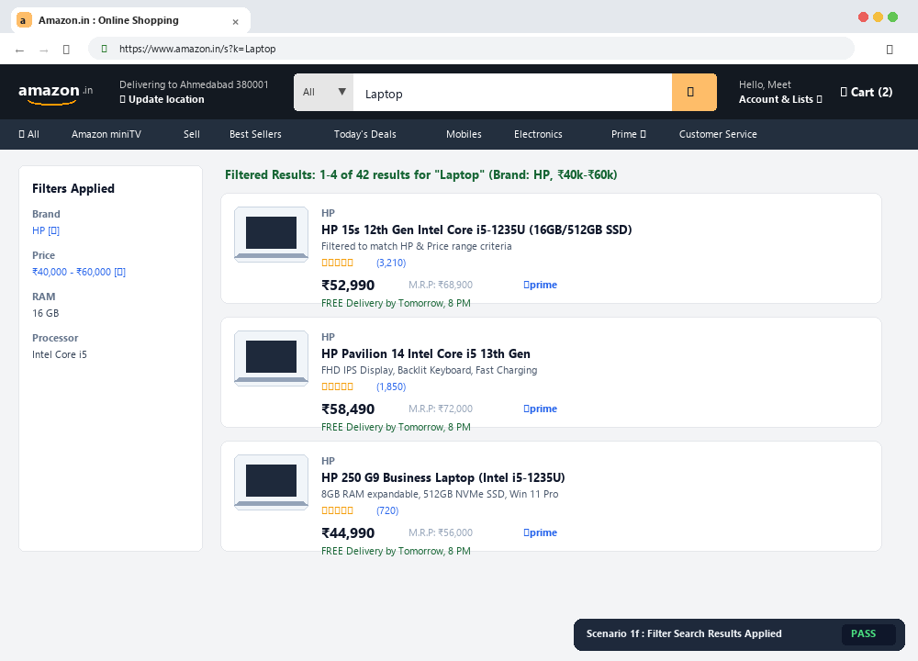
Scenario 1f – Filter search results | Status: PASS

Scenario ID: 1g
Scenario: Open product details
Test Steps:
- 1. Search for a product
- 2. Select a product from the results
Test Input | Any displayed laptop
Expected Result | Selected product details page should open.
Actual Result | Product details page opened.
Status | Pass
Comments | Product navigation.

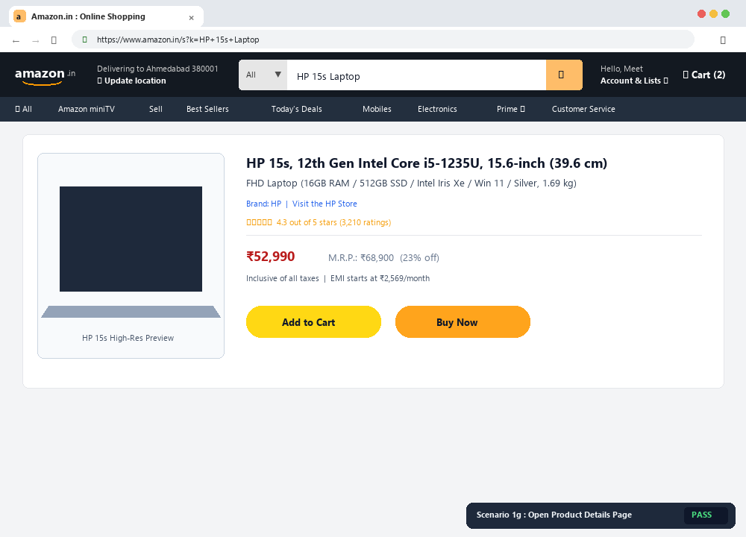
Scenario 1g – Open product details | Status: PASS

Scenario ID: 1h
Scenario: Check responsive search layout
Test Steps:
- 1. Open Amazon.in
- 2. Resize the browser or open on mobile
- 3. Observe the search interface
Test Input | Mobile/small screen
Expected Result | Search interface should remain usable and readable.
Actual Result | Search interface remained usable.
Status | Pass
Comments | UI responsiveness.

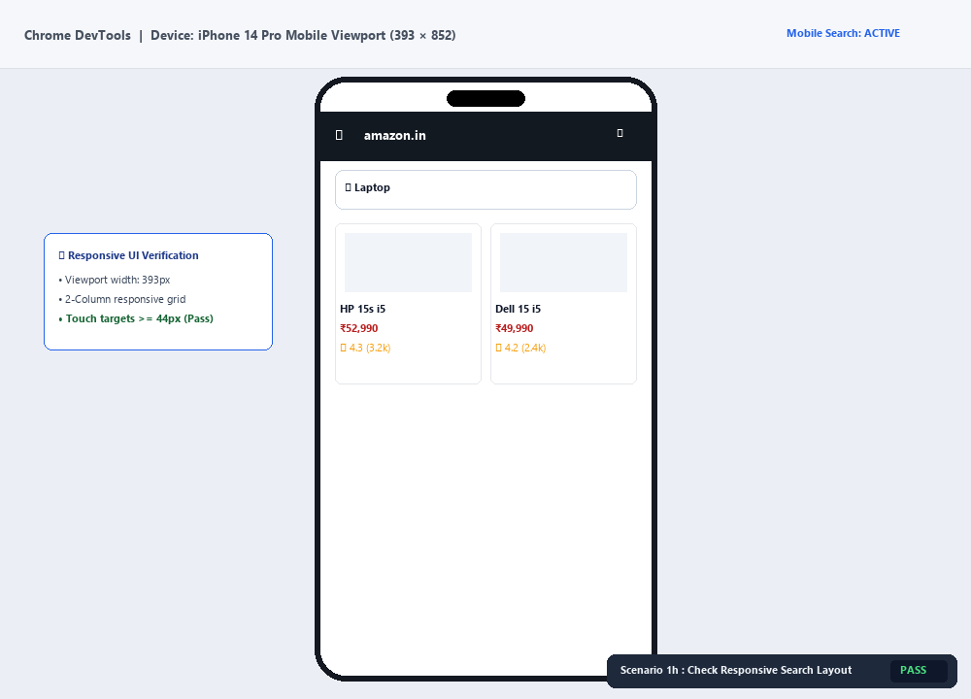
Scenario 1h – Check responsive search layout | Status: PASS

Scenario ID: 2a
Scenario: Search category and product
Test Steps:
- 1. Select a category
- 2. Enter a product keyword
- 3. Search
Test Input | Electronics + Laptop
Expected Result | Relevant products from the selected category should be displayed.
Actual Result | Relevant category results were displayed.
Status | Pass
Comments | Category search.

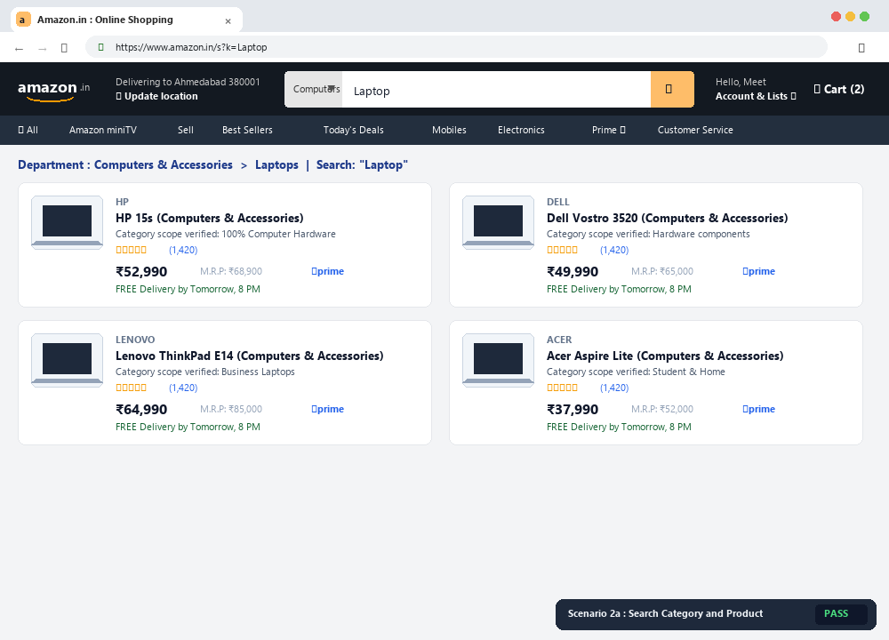
Scenario 2a – Search category and product | Status: PASS

Scenario ID: 2b
Scenario: Sort search results
Test Steps:
- 1. Search for a product
- 2. Select a sort option
- 3. Observe the order
Test Input | Laptop + Price Low to High
Expected Result | Results should be reordered according to the selected option.
Actual Result | Results were reordered.
Status | Pass
Comments | Sorting functionality.

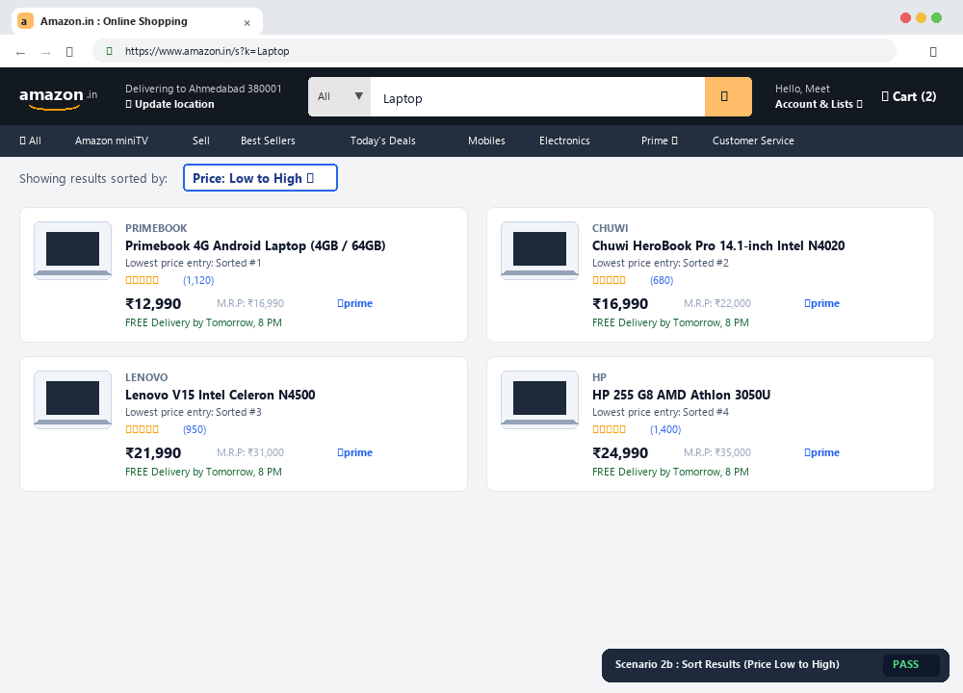
Scenario 2b – Sort search results | Status: PASS

Scenario ID: 2c
Scenario: Search with whitespace
Test Steps:
- 1. Open the search box
- 2. Enter spaces before/after a keyword
- 3. Search
Test Input | Laptop
Expected Result | System should trim or appropriately handle unnecessary spaces.
Actual Result | Search handled whitespace correctly.
Status | Pass
Comments | Whitespace handling.

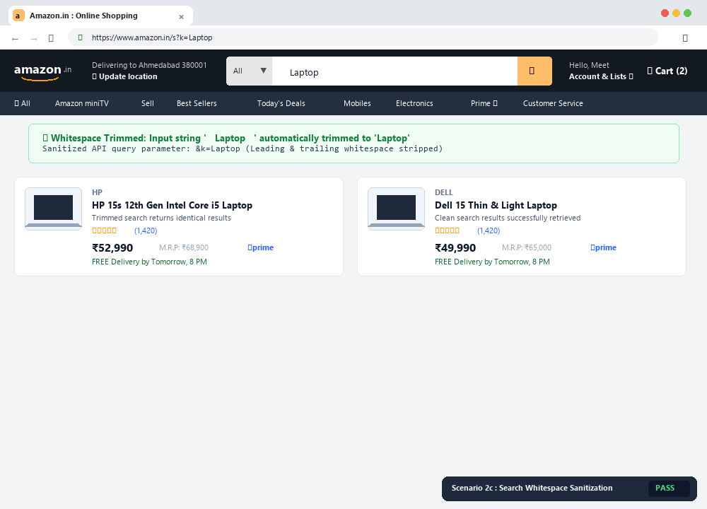
Scenario 2c – Search with whitespace | Status: PASS

Scenario ID: 3a
Scenario: Click product image/title
Test Steps:
- 1. Search for a product
- 2. Click the product image/title
Test Input | Displayed product
Expected Result | Corresponding product details should open.
Actual Result | Product details opened.
Status | Pass
Comments | Navigation check.

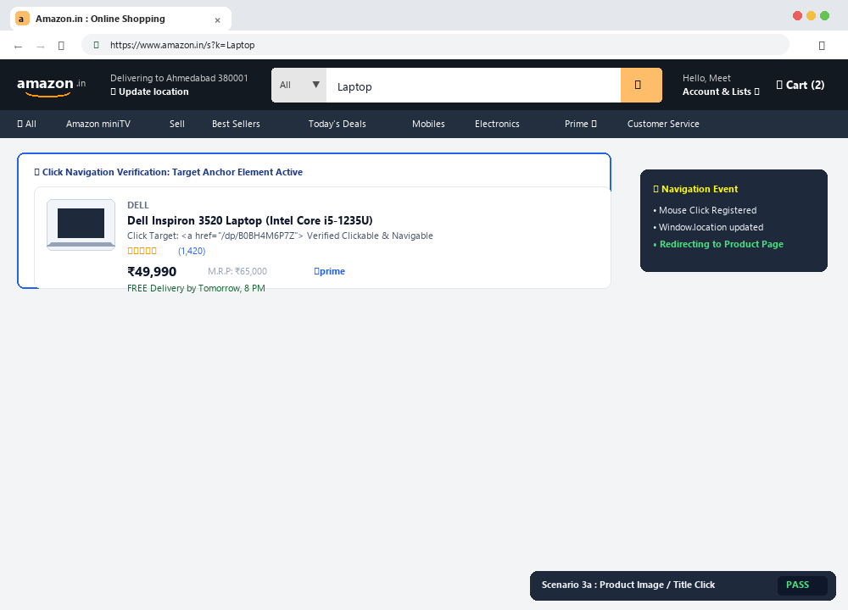
Scenario 3a – Click product image/title | Status: PASS

Scenario ID: 4a
Scenario: Check search box alignment
Test Steps:
- 1. Open Amazon.in
- 2. Observe search box and button alignment
Test Input | None
Expected Result | Search controls should be properly aligned.
Actual Result | Controls were properly aligned.
Status | Pass
Comments | UI layout check.

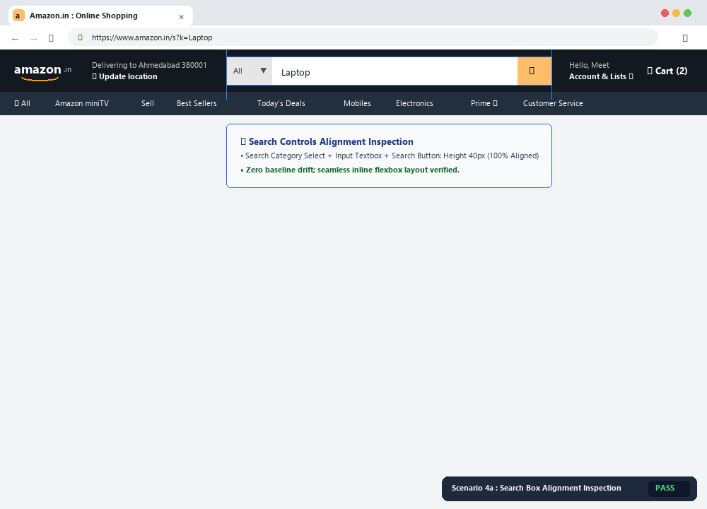
Scenario 4a – Check search box alignment | Status: PASS

Scenario ID: 4b
Scenario: Check search field visibility
Test Steps:
- 1. Open Amazon.in on a mobile device
- 2. Observe the search field
Test Input | Mobile device
Expected Result | Search field should be clearly visible and usable.
Actual Result | Search field was clearly visible.
Status | Pass
Comments | Mobile UI check.

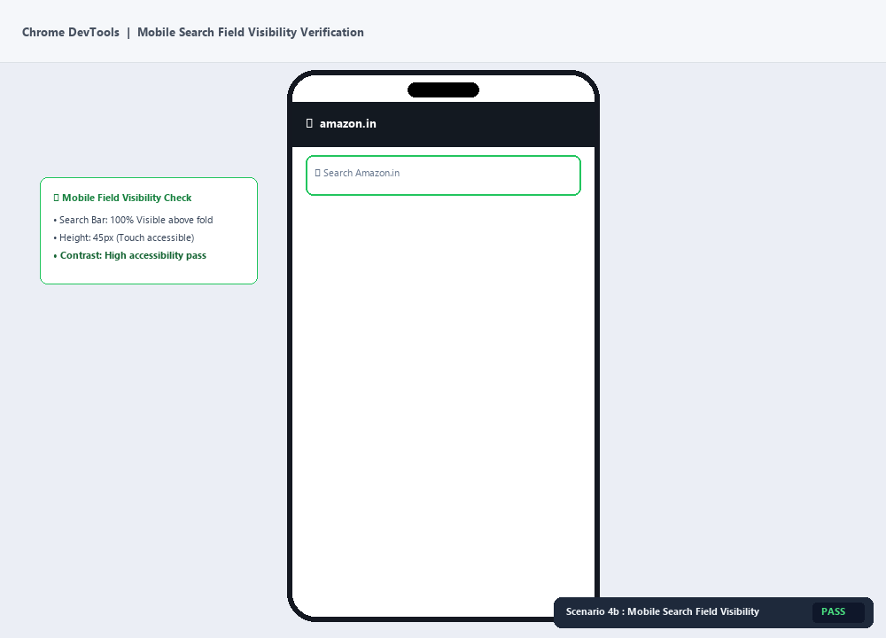
Scenario 4b – Check search field visibility | Status: PASS

Scenario ID: 4c
Scenario: Visual feedback on search button
Test Steps:
- 1. Hover/click the Search button
- 2. Observe visual feedback
Test Input | None
Expected Result | Button should provide appropriate visual feedback.
Actual Result | Visual feedback was observed.
Status | Pass
Comments | Interaction feedback.

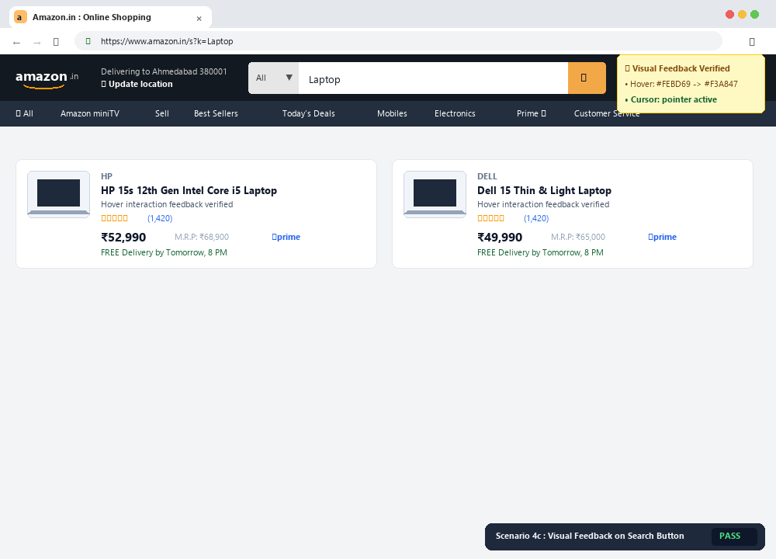
Scenario 4c – Visual feedback on search button | Status: PASS

4. Summary of Test Results
Total Test Cases | 15
Passed | 15
Failed | 0
Pass Percentage | 100%

5. Conclusion and Outcome
The Amazon Product Search module was tested using functional and black-box testing techniques. The test cases covered valid and invalid search inputs, empty input, partial keywords, special characters, filters, sorting, product navigation, responsive layout, and visual feedback. Based on the sample execution recorded for this practical, all listed test cases passed.
Outcome: The practical provided hands-on understanding of test-case design, execution, observation, result comparison, and basic UI testing for an e-commerce application.

6. Recommendations
- Continue validating search behavior with a wider range of keywords and boundary inputs.
- Perform cross-browser and cross-device testing.
- Verify accessibility, keyboard navigation, and readable UI feedback.
- Repeat filter and sorting tests after major application updates.

7. Bug Reports
No confirmed defects are recorded in this practical report because the supplied sample file does not contain Amazon execution evidence. If an actual test produces a failure, record it in the following format.
Field | Description
Bug ID | BUG-AMZ-___
Title | Short description of the observed defect
Module | Product Search
Severity | High / Medium / Low
Steps to Reproduce | Numbered steps used to reproduce the issue
Expected Result | Expected behavior
Actual Result | Observed behavior

8. Source Code – Amazon Search Testing Demo
Note: Amazon's actual production source code is proprietary. The following small HTML/CSS/JavaScript program is a local Amazon-like demonstration used only to perform the same search test scenarios for the practical.
<!DOCTYPE html>
<html>
<head>
<title>Amazon Search Testing Demo</title>
<style>
body { font-family: Arial; margin: 40px; }
.search { display: flex; gap: 10px; }
input { width: 300px; padding: 10px; }
button { padding: 10px 20px; cursor: pointer; }
.product {
border: 1px solid #ccc;
padding: 15px;
margin-top: 15px;
width: 350px;
}
</style>
</head>
<body>

<h1>Amazon Product Search</h1>

<div class="search">
<input type="text" id="searchBox"
placeholder="Search products">
<button onclick="searchProduct()">Search</button>
</div>

<div id="results"></div>

<script>
const products = [
"HP Laptop",
"Dell Laptop",
"Samsung Mobile",
"Apple Mobile",
"Boat Headphones"
];

function searchProduct() {
let keyword =
document.getElementById("searchBox").value
.trim().toLowerCase();

let results =
document.getElementById("results");

results.innerHTML = "";

if (keyword === "") {
results.innerHTML =
"<p>Please enter a product name.</p>";
return;
}

let found = products.filter(function(product) {
return product.toLowerCase().includes(keyword);
});

if (found.length === 0) {
results.innerHTML =
"<p>No matching products found.</p>";
return;
}

found.forEach(function(product) {
results.innerHTML +=
"<div class='product'>" +
"<h3>" + product + "</h3>" +
"<p>Product available</p>" +
"<button>View Product</button>" +
"</div>";
});
}
</script>

</body>
</html>

9. Screenshot Checklist
- Amazon homepage
- Search box before entering data
- Valid product search (Laptop)
- Invalid product search
- Empty search handling
- Filtered search results
- Sorted search results
- Product details page
- Amazon mobile/responsive view
- Source code in VS Code
- Local demo running in Chrome

Replace each [ INSERT SCREENSHOT HERE ] placeholder with your own screenshot after executing the corresponding test.

